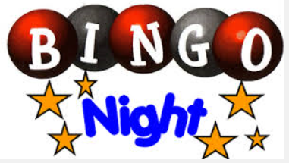
AT ST ROCH’S SECONDARY SCHOOL
Thursday 8 December 2016 AT 7PM
(50p Entry Fee. Rhymer st Entrance)
BINGO BINGO GET YOUR DABBERS OUT
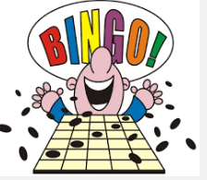
BINGO BINGO DON’T FORGET TO SHOUT
COME ALONG AND JOIN THE FUN
LOTS OF PRIZES TO BE WON
TOMBOLA, TEA AND BISCUITS TOO
A perfect night out for you
Come along and help us in this fundraising event for the school

